S.KAVIYA PRIYA

|  |  |  |
| --- | --- | --- |
| S.NO | TEAM MEMBERS | NAAN MUDHALVAN ID |
| 1 | S.Kaviya Priya | 6E4AEC31C6AE24DA3E549D9B7D4C2645 |
| 2 | A.Dhivya | 769F95874FE4282869C4E22439F8A5FC |
| 3 | G.Kaviya | 1904C349F7F1A08A46049E3047754FF8 |
| 4 | S.Nivethitha | BC6AD3BDAD820A5A79C49EA8333B91D3 |

**TEAM ID:** NM2023TMID02080

**PROJECT DISCRIPTION**

**MOONGLADE JEWELLERY**

Jewellery has always been a symbol of beauty and self-expression. It holds the power to enhance one's appearance and make a statement about their personality. Among the vast array of jewellery brands available in the market, Moonglade Jewellery stands out for its unique fusion of elegance and nature-inspired designs.

Moonglade Jewellery is a brand that takes inspiration from the natural world, incorporating elements such as moonlight, flowers, and celestial bodies into their designs. Each piece is meticulously crafted to capture the essence of these elements, resulting in exquisite and captivating jewellery.

**BRAND NAME :** MOONGLADE JEWELLERY

**BRAND LOGO**



**BRAND EMAIL :** [moongladejewellery@gmail.com](mailto:moongladejewellery@gmail.com)

**MAILCHIMP LANDING PAGE URL:** <https://mailchi.mp/7df30f121e45/moongladejewellery>

**PASSWORD:**moongladejewellery03

STEPS TO CREATE A LANDING PAGE USING MAILCHIMP

STEP 1

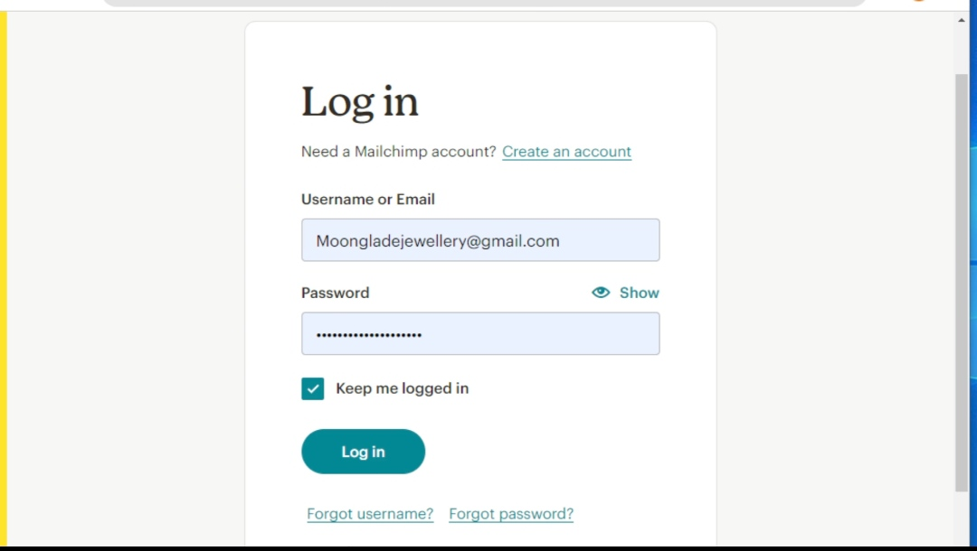

STEP 2

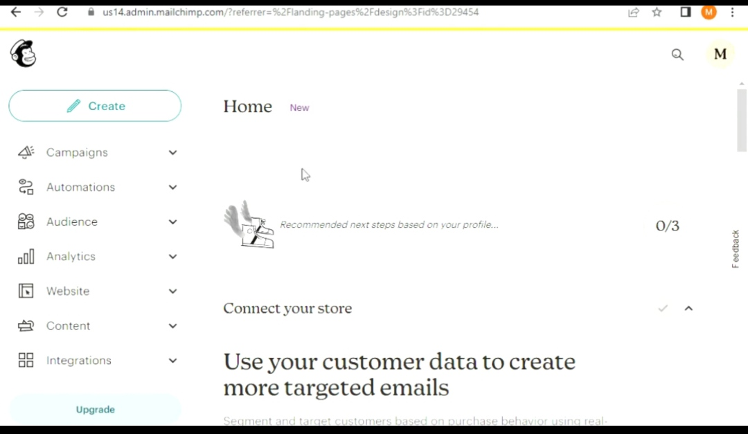

STEP 3

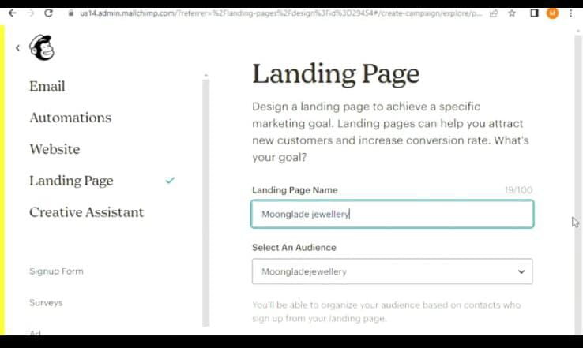

STEP 4

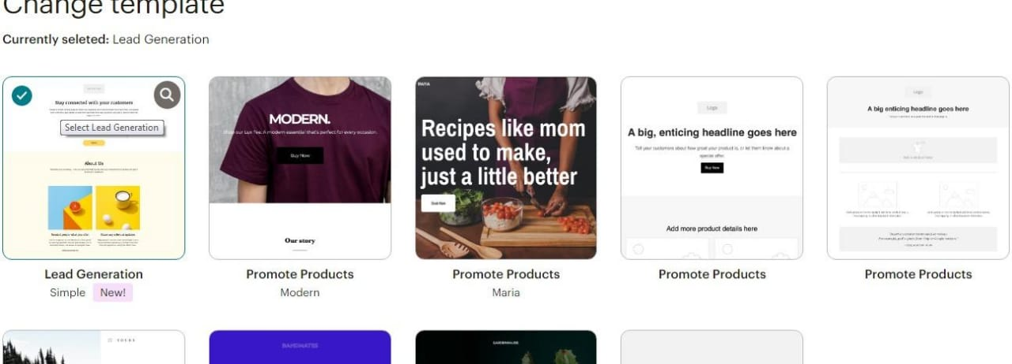

STEP 5

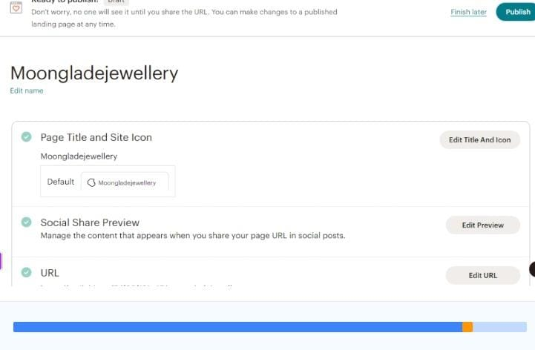

STEP 6

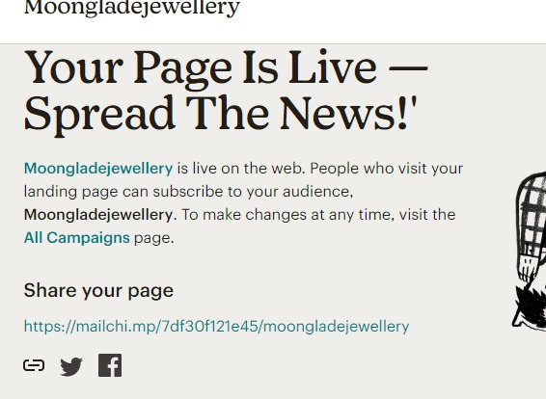

DEMO VIDEO

<https://youtu.be/doevjKEfAs4?si=zBuK1nqE0INo8E4v>